Parts Database Project Proposal
Eric Dahlenburg

Identify Business Problem:
Non-Stock Listed(NSL) parts are parts that are not available through the Federal Stock system and must be purchased outside the Kennedy space center through retail channels. 90% of the repair parts purchased are under $10. The procurement process costs roughly $200 in labor cost per vendor order. This ends-up costing $210 for one part on average. Because of this, extra parts are ordered for future use. These extra parts can sit on a technicians desk for years without ever being used. Meanwhile, another technician might order the exact same part for a repair, not knowing that the part is on-base. This database will allow all users to search for needed parts before ordering their purchase.

Business Identity:
The parts database will track Non-Stock Listed (NSL) parts for re-use within the Intermediate Level Maintenance Facility(ILMF) and other entities throughout United Space Alliance(USA). Note: The Authors employer and department.

Basic Requirements:
The database application will run over a Windows based local server with roughly 30 networked users. Parts entry will be performed by one individual with the proper server privileges. All end-users should be able to run the canned queries listed below. Currently, there is no database or other method for tracking these NSL parts.

Queries the database should answer for the operator:

1. Search for part by Generic Part Number(s) including wildcard usage.
2. Search for part by Stock Number(s) including wildcard usage.
3. Search for part by Alternate Part Number(s) including wildcard usage.
4. Search for parts by nomenclature including wildcard usage.
5. Determine the last date that a part was used.
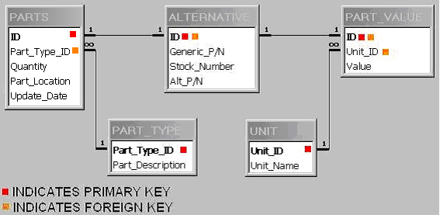
6. Determine which parts are almost depleted (zero balance).
Figure 1. Rough plan of Tables and Relationships

